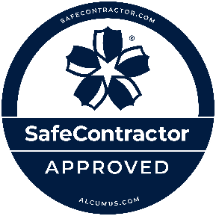

**Top Safety Accreditation for** **Rediweld Traffic Products Ltd.**

We are pleased to announce that as a local business in Alton, Hampshire

Rediweld Traffic Products Ltd has been awarded accreditation from Alcumus SafeContractor for achieving excellence in Health and Safety in the workplace.

Alcumus SafeContractor is a leading accreditation scheme which recognises extremely rigorous standards in health and safety management amongst contractors. It is used by thousands of organisations in the UK including SMEs and FTSE 100 companies.

Rediweld Traffic Products Ltd is principally involved in the Public and Private sectors, specialising in the manufacturing, supply and installation of highway products, manufactured from recycled rubber.

The company’s application for SafeContractor accreditation was driven by the need for a uniform standard across the business. SafeContractor accreditation will enhance the company’s ability to win new contracts, and its commitment to safety will be viewed positively by its insurers when the company liability policy is up for renewal.

Gaining the SafeContractor accreditation to the business, enhances the services, products and quality we offer to our customers.

For further information, contact:

**Jeanette Holder, Managing Director**

**jeanette.holder@rediweldtraffic.co.uk**

**www.rediweldtraffic.co.uk**